# Automatic Configuration Tool

One problem facing organizations and entities that frequently configure new instances of ePO, is the time and consistency in making sure everything has been done properly.

The goal of this tool is to provide:

* Organization
* Consistency
* Simplicity
* Efficiency

This is achieved by preparing an archive of files that will be used by a script to import all of the desired items into the target ePO server, in the chosen order.

These are:

* Master Repository
* Installed Extensions
* Policies
* Preconfigured Tasks

This solution, with a minor amount of preparation, performs these tasks quickly and easily

This ePO Automatic Installation tool performs these tasks from a simple configuration file

# The Layout

The configuration file (config.yaml) is a standard YAML file. The first element is the Group, followed by Files, then each Filename and Type.

Types:

Package is a ZIP file as would be checked into ePO within the ePO standard interface

Options: None

Extension is a ZIP file as would be installed into ePO within the ePO standard interface

Options: Order: *integer*

Order is used to define the order of extension installation. It is a global counter, so if there are dependencies outside of the group of files, that can be accounted for. If this is not desired, a simple change can be made to localize the order within the group.

Policy is an XML file as would be exported/imported within the ePO standard interface

Options: None

Task is an XML file as would be exported/imported within the ePO standard interface

Options: None

Example:

Solidcore is the first Group

VSE is the second Group

Extension installation order:

Solidcore_epo_extn_8.2.1.229.zip

VIRUSCAN8800(732).zip

VIRUSCANREPORTS120(452).zip

epo45_help_vse_880.zip

Solidcore:

  Files:

    - Filename: "SOLIDCOR821-435_WIN.zip"

      Type: Package

    - Filename: "Solidcore_epo_extn_8.2.1.229.zip"

      Type: Extension

      Order: 1

    - Filename: "Colby.xml"

      Type: Policy

    - Filename: "Tasks_for_Solidcore.xml"

      Type: Task

VSE:

  Files:

    - Filename: "VSE880LMLRP14.zip"

      Type: Package

    - Filename: "VIRUSCAN8800(732).zip"

      Type: Extension

      Order: 2

    - Filename: "VIRUSCANREPORTS120(452).zip"

      Type: Extension

      Order: 3

    - Filename: "epo45_help_vse_880.zip"

      Type: Extension

      Order: 4

Execution

*\* Note: This must be executed on the ePO Server itself*

Once you have created your config file, place all of the files to be used into the same folder as the executable and config file, then execute Auto Installer.exe

You’ll be prompted for ePO Server IP, Username, and Password. Then, it will connect to the ePO server and:

* Installing the extensions in the order desired
* Check in the Packages defined
* Import the Policies defined
* Import the Tasks defined

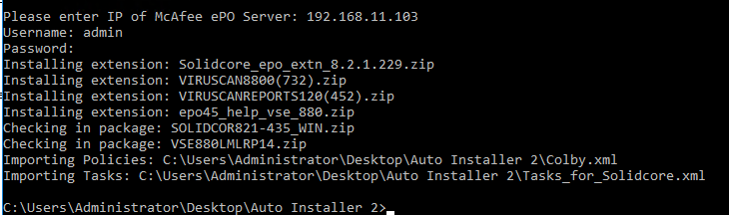

All that’s left to do is begin using your newly configured ePO server.